

**Course Name: Software Quality Assurance**

Course Code: CSE435(sec-3) Summer21

**Project Report Part-2**

**Submitted to:**

Dr. Shamim H Ripon Professor,Department of CSE East West University

**Submitted By:**

1.Najia Anjum (ID: 2018-1-60-125)

2. Ehsanul Haque (ID: 2018-1-68-079)

3. Aftab Miraj Swachchha (ID:2017-2-60-074)

**EWU-CONNECT**

Project Description:

**EWU CONNECT** is a virtual community platform designed exclusively for the students of East West University where they can connect with their faculties, clubs, communities and the university as a whole. Only EWU members can be registered and registered members can submit links, text posts, images. which are then voted up or down by other members in the same

community. Posts are arranged by tops into a user-created group called "community" which

cover up many topics like news, EWU club activity, events, movies, video games, music, books and image-sharing. Post that has more up-votes appears at the top of their community, if the post receives enough upvotes, eventually on the site's front page. Even with strict rules prohibiting harassment, Community administrators can moderate the site.

Sequence Diagrams:

1. **Sequence Diagram of Create Community:**

User requests to create a new community, then the website will display community form. After submitting information, the website will request tagname count to the database. Then the database will execute a query for tagname and return it to the website. After getting the tagname website will query for saving new communities to the database, then the database will save the information and return ok requests to the website. If the tagname count is equal to 0 the website will allow user access and redirect user to community, else tagname count is not unique, website will deny access and show error message to the user.

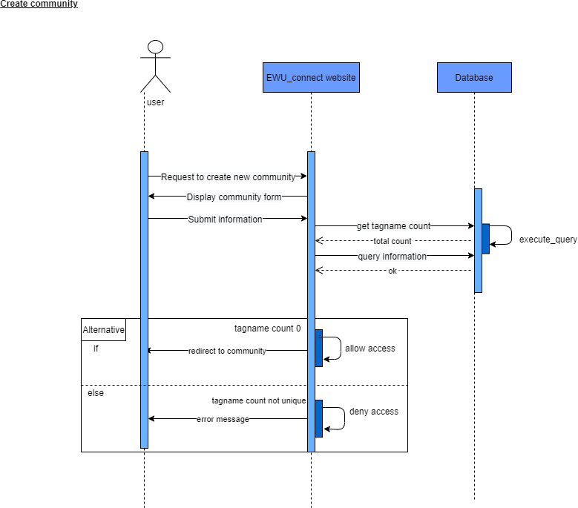

PROMELA Code:

mtype = {req_to_create_new_community, display_community_form, submit_information, error_message, tagname_count, query_information, execute_query,redirect_to_community, allow_access, tagname_count_not_unique, receive_querry, website_login, ok, deny_access};

chan toUser = [1] of {mtype,bit}; chan toWebsite = [1] of {mtype,bit}; chan toDatabase = [1] of {mtype,bit}; bool success = 1;

proctype User(chan in, out)

{

bit sendbit, recvbit; do

:: out ! req_to_create_new_community, sendbit; in ? redirect_to_community, recvbit;

if

:: recvbit == 1 -> in ? submit_information, recvbit -> out ! display_community_form, sendbit;

:: recvbit == 0 -> in ? tagname_count_not_unique, recvbit -> out ! error_message, sendbit;

fi od

}

proctype Website(chan in, out, db)

{

bit sendbit, recvbit; do::

in ? req_to_create_new_community(recvbit); db ! query_information, sendbit ->

in ? receive_querry, recvbit; in ? ok, recvbit ->

db ! execute_query, sendbit; if

:: sendbit == 0 ->

sendbit = 1; out ! redirect_to_community(sendbit);

:: sendbit == 1 ->

sendbit = 0; out ! redirect_to_community(sendbit); fi

if

:: sendbit == 1 -> out ! submit_information(sendbit) ->

in ? display_community_form(recvbit);

:: sendbit == 0 -> out ! tagname_count_not_unique(sendbit) -> in ? error_message(recvbit);

fi od

}

proctype Database(chan in, out)

{

bit recvbit, sendbit; do::

in ? query_information(recvbit) -> out ! receive_querry(recvbit);

in ! website_login(recvbit); in ? website_login(recvbit); out ! ok(recvbit) ->

in ? execute_query(recvbit); od

}

init

{

run User(toUser, toWebsite);

run Website(toWebsite, toUser, toDatabase); run Database(toDatabase, toWebsite);

}

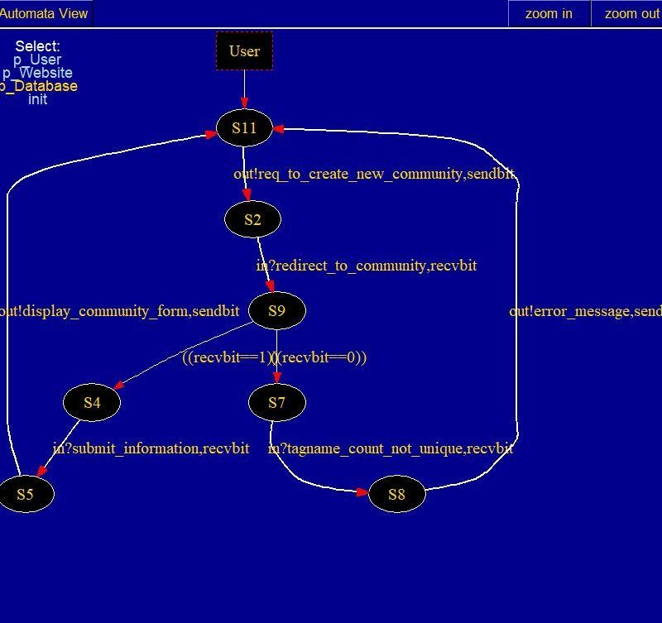

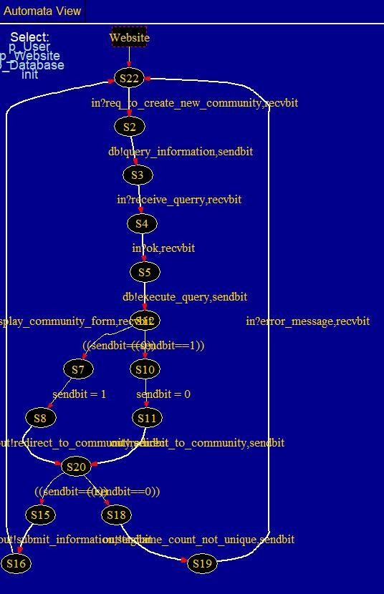

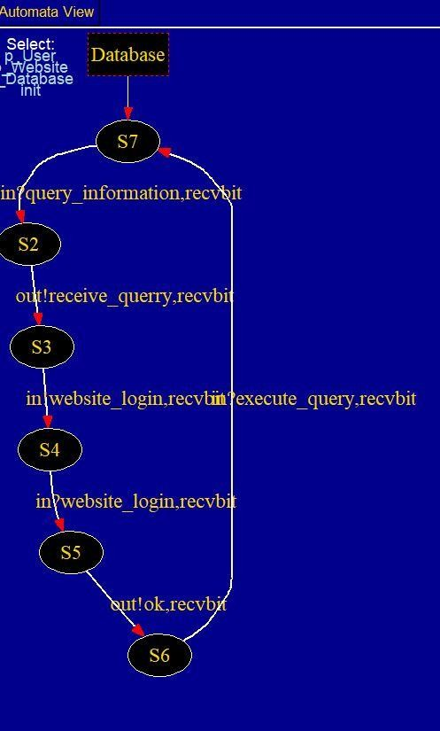

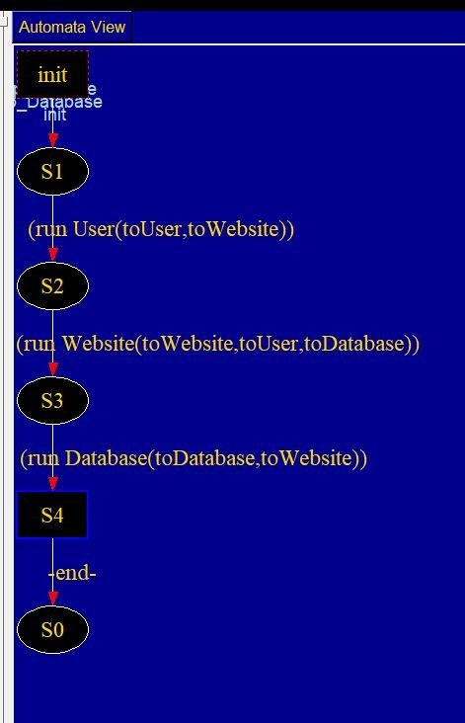

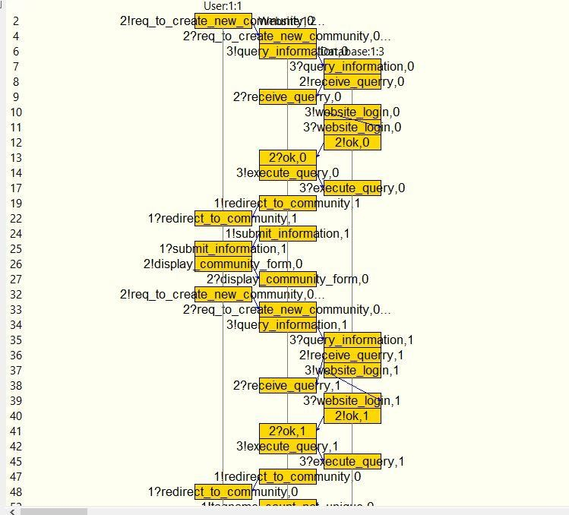

1. **Sequence Diagram of Edit Community Details:**

User requests to update the community database to the website, it will display the form. After

submitting information, the website will validate that information. If the tagname is unique, the website will send information to the database. Then the database will store the data and return an

‘ok’ response to the website and it will show an ‘ok’ message to the user. If the tagname count is not unique, the website will show an error message to the user.

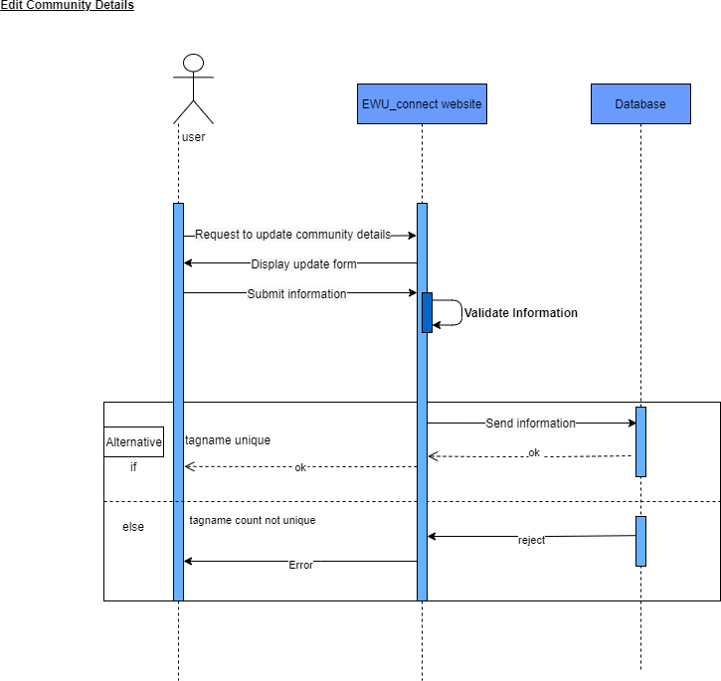

PROMELA code:

mtype = {req_to_update_community, display_update_form , submit_information, validate_info, receive_input, tag_name_unique,send_confirnation_user, database_update, send_confirmation_website, send_error}

chan toUser = [1] of {mtype,bit}; chan toWebsite = [1] of {mtype,bit}; chan toDatabase = [1] of {mtype,bit}; proctype User(chan in, out)

{

bit sendbit, recvbit;

do

:: out ! req_to_update_community, sendbit; in ? display_update_form, recvbit;

out ! submit_information, sendbit; out ! validate_info, sendbit;

in ? send_error, recvbit; od

}

proctype Website(chan in, out, db)

{

bit sendbit, recvbit;

do::

in ? req_to_update_community(recvbit); out ! display_update_form(sendbit);

in ? submit_information(recvbit); in ? validate_info(recvbit);

in ! target_name_unique(recvbit); in ? target_name_unique(recvbit);

db ! send_confirnation_user, sendbit -> in ? send_confirmation_website, recvbit; out ! send_error(sendbit);

od

}

proctype Database(chan in, out)

{

bit recvbit, sendbit; do

:: in ? send_confirnation_user(recvbit) -> out ! send_confirmation_website(recvbit); od

}

init

{

run User(toUser, toWebsite);

run Website(toWebsite, toUser, toDatabase); run Database(toDatabase, toWebsite);

}

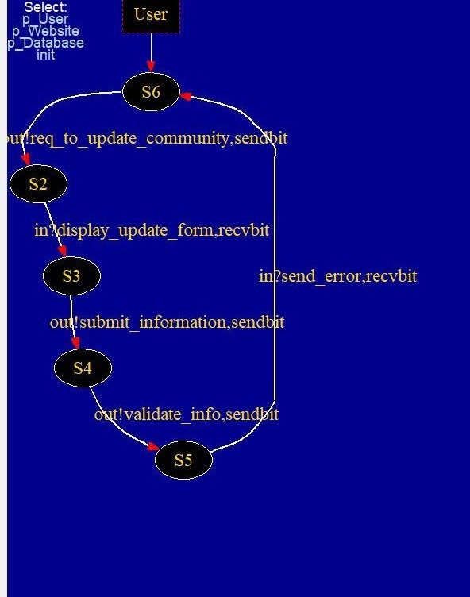

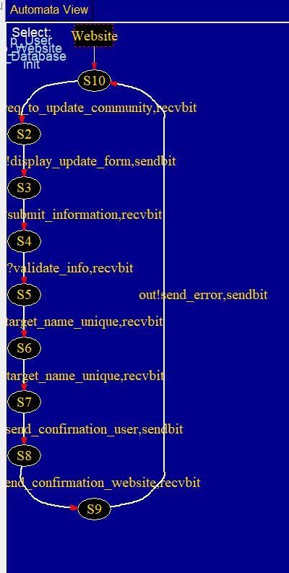

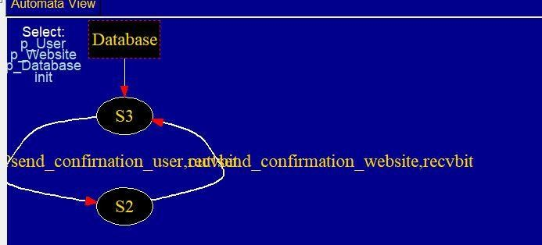

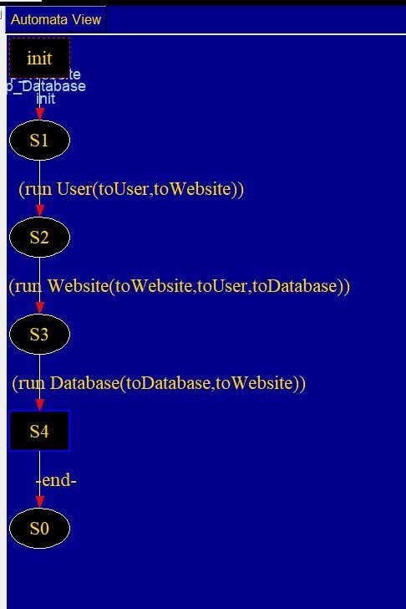

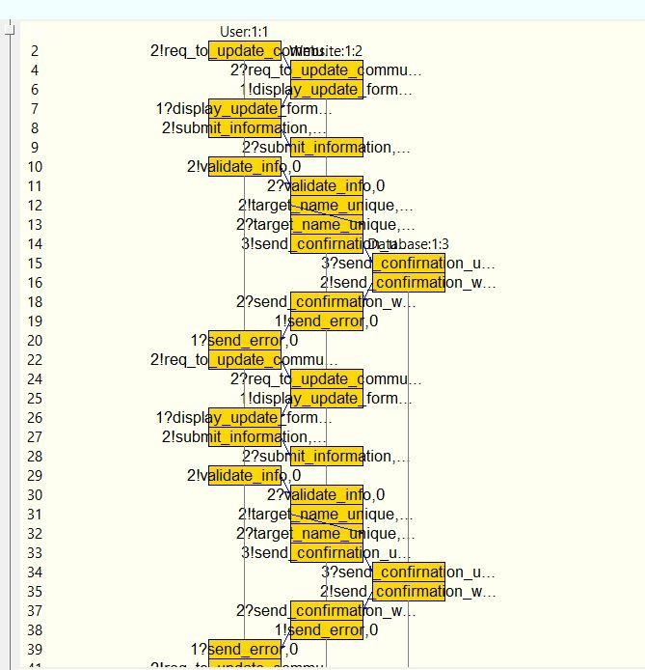

1. **Sequence Diagram of Update Profile Information:**

User will request for editing his/her profile on the website. It will return the profile edit form to the user. After filling up and submitting the form, the website will query to the database with new information. After successfully saving that information on the database, it will return a

success response to the website, then the website will show a success message to the user.

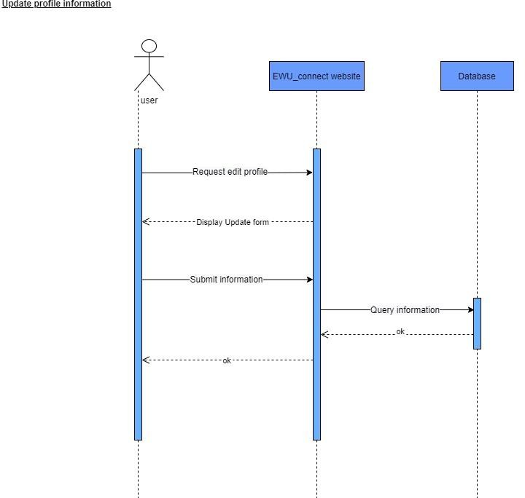

PROMELA Code:

mtype = {request_edit_profile, display_update_form , submit_information, query_information,ok_user, ok_db}

chan toUser = [1] of {mtype,bit}

chan toWebsite = [1] of {mtype,bit}; chan toDatabase = [1] of {mtype,bit}; proctype User(chan in, out)

{

bit sendbit, recvbit;

do

:: out ! request_edit_profile, sendbit; in ? display_update_form, recvbit; out ! submit_information, sendbit;

od

}

proctype Website(chan in, out, db)

{

bit sendbit, recvbit;

do::

in ? request_edit_profile(recvbit); out ! display_update_form(sendbit); in ? submit_information(recvbit);

db ! ok_user, sendbit -> in ? ok_db, recvbit;

od

}

proctype Database(chan in, out)

{

bit recvbit, sendbit; do

:: in ? ok_user(recvbit) -> out ! ok_db(recvbit);

od

}

init

{

run User(toUser, toWebsite);

run Website(toWebsite, toUser, toDatabase); run Database(toDatabase, toWebsite);

}

